

**QGIS Lab Series**

**GST 102: Spatial Analysis**

**Lab 1: Reviewing the Basics of Geospatial Data**

**Objective – Explore data structures, file types, coordinate systems and attributes**

**Document Version:** **2014-07-12 (Final)**

**Author:**

Kurt Menke, GISP



**Contents**

1 Introduction 2

2 Objective: Use Basic Spatial Analysis Techniques to Solve a Problem 2

3 How Best to Use Video Walk Through with this Lab 2

Task 1 GIS Data – Vector 3

Task 2 GIS Data - Raster 4

Task 3 Geodatabase 5

Task 4 Coordinate Systems 10

Task 5 GIS Data Attributes and Attribute Tables 11

5 Conclusion 11

6 Discussion Questions 12

1. Introduction

This exercise features questions and activities designed to review some basic GIS and geospatial concepts. Please complete the exercise and turn in when you are finished. When asked to do something in the software, create a screen capture and put it into this document.

This lab includes the following tasks:

* Task 1 – GIS Data - Vector
* Task 2 – GIS Data – Raster
* Task 3 - Geodatabases
* Task 4 – Coordinate Systems
* Task 5 – GIS Data Attributes and Attribute Tables

1. Objective: Use Basic Spatial Analysis Techniques to Solve a Problem

Spatial Analysis is a crucial aspect of GIS; the tools allow the user to analyze the patterns and relationships of the various data. Understanding the concepts of data structures, the variety of file formats, coordinates systems, and attributes are necessary in the design and the function of spatial analysis.

There are two main data models within the GIS realm:

* **Vector** – a representation of the world using points, lines and polygons. Vector data is useful for storing data that has discrete boundaries.
  + **Points** – use a single coordinate pair to define a location.
  + **Lines** – uses an ordered set of coordinates to define a linear feature.
  + **Polygons** – an area feature formed by a connected set of lines.
* **Raster** – a representation of the world as a surface divided into a regular grid of cells. Raster models are useful for storing data that varies continuously such as an aerial photograph.

Discrete and Continuous objects:

* **Discrete** – Data that represents phenomena with distinct boundaries. Property lines and streets are examples of discrete data. Discrete data can be stored via vector or raster data models.
* **Continuous** – Data such as elevation or temperature that varies without discrete steps. Continuous data is usually represented by raster data.

Some Common Data Management Options:

* **Shapefile** – a GIS file format for vector data.
* **GeoTiff –** a GIS file format for raster data.
* **ERDAS Imagine *.**img – a GIS file format for raster data
* **Geodatabase** – a relational database capable of storing GIS data layers.

1. How Best to Use Video Walk Through with this Lab

To aid in your completion of this lab, each lab task has an associated video that demonstrates how to complete the task. The intent of these videos is to help you move forward if you become stuck on a step in a task, or you wish to visually see every step required to complete the tasks.

We recommend that you do not watch the videos before you attempt the tasks. The reasoning for this is that while you are learning the software and searching for buttons, menus, etc…, you will better remember where these items are and, perhaps, discover other features along the way. With that being said, please use the videos in the way that will best facilitate your learning and successful completion of this lab.

1. GIS Data – Vector

You will examine the vector lab exercise data using QGIS Browser.

1. The data for this lab is located on the lab machine at: *C:\GST102\Lab 1\Data.*
2. **Open QGIS Browser 2.2.0.**
3. Expand the GST 102\Lab 1\Data folder, so that the data are visible in the File Tree. You should see 7 shapefiles, an ERDAS Imagine img file and a tif file along with several XML metadata files.
4. To study the properties of each file select each one and choose the **Metadata** tab (**Figure 1**).

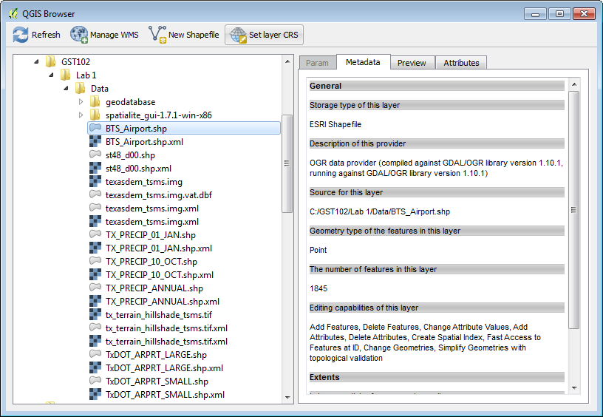

**Figure 1: QGIS Browser Metadata Tab**

1. Studying the properties of each of the shapefiles listed below, write down **the geometry type** (point, line, polygon) and the **number of features** in the space provided below.

**Question # 1**

* 1. **BTS_Airport.shp**
     1. Geometry:
     2. Number of Features:
  2. **St48_d00.shp**
     1. Geometry:
     2. Number of Features:
  3. **TX_PRECIP_01_JAN.shp**
     1. Geometry:
     2. Number of Features:
  4. **TX_PRECIP_ANNUAL.shp**
     1. Geometry:
     2. Number of Features:
  5. **TxDOT_ARPRT_SMALL.shp**
     1. Geometry:
     2. Number of Features:

1. GIS Data - Raster

Now you will examine the raster datasets provided with this lab.

1. **Open QGIS Browser 2.2.0.**
2. Expand the GST 102\Lab 1\Data folder, so that the data are visible in the File Tree. Along with the shapefiles you will see an ERDAS Imagine raster img file and a GeoTiff file along with several XML metadata files.
3. To study the properties of each raster, select each one, and choose the **Metadata** tab.
4. Record the file format. This will be listed under the **Driver** section. (You can record the last line of that description which is the file format.) You will also record the pixel **Dimensions** and the **Spatial Reference System** in the space provided below.

**Question # 2**

* 1. **Texasdem_tsms.img**
     1. File format:
     2. Dimensions:
     3. Spatial Reference System:
  2. **tx_terrain_hillshade_tsms.tif**
     1. File format:
     2. Dimensions:
     3. Spatial Reference System:

**Question # 3**: Do these look to be discrete or continuous raster datasets?

1. Geodatabase

This task will introduce you to another file format, the geodatabase. You’ll use QGIS Desktop to connect to, and explore the data contained in a SpatiaLite database. SpatiaLite is a SQLite database engine with spatial functions added. This means that spatial data layers can be stored in the relational database.

1. **Open QGIS Desktop 2.2.0**
2. Click the **Add SpatiaLite Layer** button  opening the **Add SpatiaLite Table(s)** window.
3. Click the **New** button to establish a connection to a SpatiaLite database.
4. **Select** the C:\GST102\Lab 1\Data\geodatabase\NDG.sqlite file and click **Open**.
5. **Click Connect** in the **Add SpatiaLite Table(s)** window (**Figure 2**).

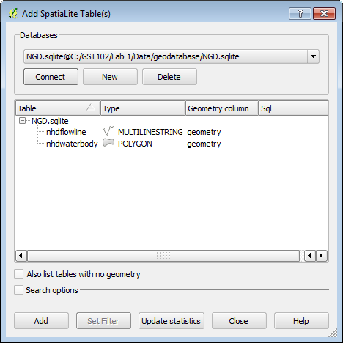

**Figure 2: Add SpatiaLite Table(s)**

1. You will see two layers: nhdflowline and nhdwaterbody. **Select** both by clicking on them with the **Ctrl** key held down.
2. **Click Add** to add them to QGIS (**Figure 3**).

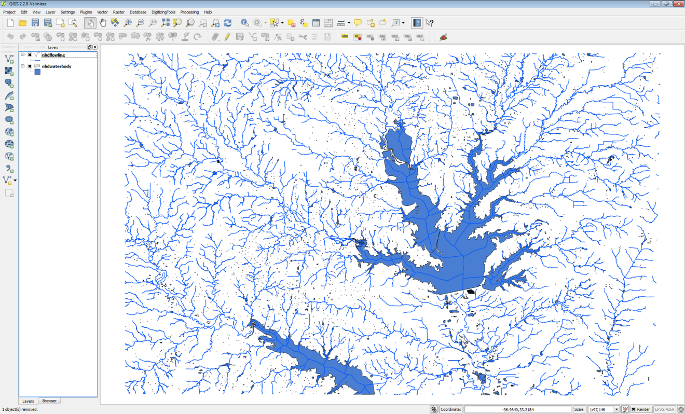

**Figure 3: SpatiaLite Layers in QGIS Desktop**

1. Now you will import a shapefile into the NDB SpatiaLite geodatabase. From the menu bar **choose** **Database 🡪 DB Manager** to open the **DB Manager** window. Expand the **SpatiaLite** section and the NGD.sqlite geodatabase. You will see the two layers and many other tables (**Figure 4**). These other tables store information about the geometry and coordinate reference systems of GIS data.

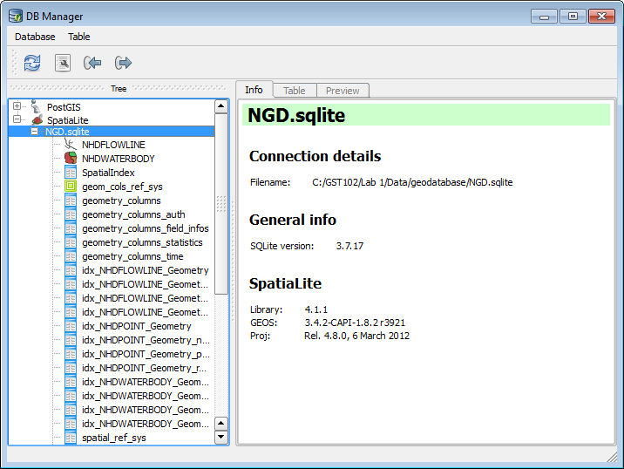

**Figure 4: DB Manager**

1. Click the **Import Layer/File**  button to open the Import vector layer window.
2. Click the ellipsis  button to the right of the **Input** section to open the **Choose the file to import** window. Navigate to C:\GST102\Lab 1\Data\geodatabase folder and **select** **NHDPOINT.shp**. Click **Open**.
3. Name the **Output** table ‘**nhdpoint’**. Make sure **Create new table** option is checked. Under **Options** check **Source SRID** and type in **4269**. This is the EPSG code for the geographic coordinate system NAD83. This is the CRS of the NHDPOINT shapefile (**Figure 5**). Click **OK**.

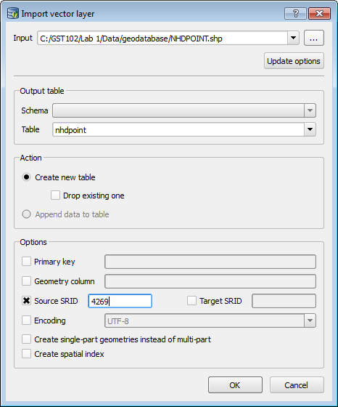

**Figure 5: Import Vector Layer**

1. You should get a message that the **Import was successful**. Click **OK**.
2. Click the **Refresh**  button on the **DB Manager**. You should now see nhdpoint listed as a new table in the database with a point icon  (**Figure 6**).

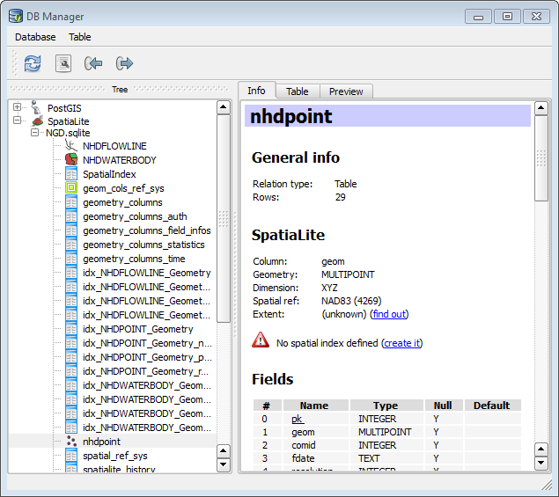

**Figure 6: DB Manager with new layer imported**

1. Right click on the nhdpoint layer in the **DB Manager** and choose **Add to canvas**. Close the DB Manager.



1. You should now see the new point data added to QGIS (**Figure 7**). You have connected to a geodatabase and imported a shapefile into the database.

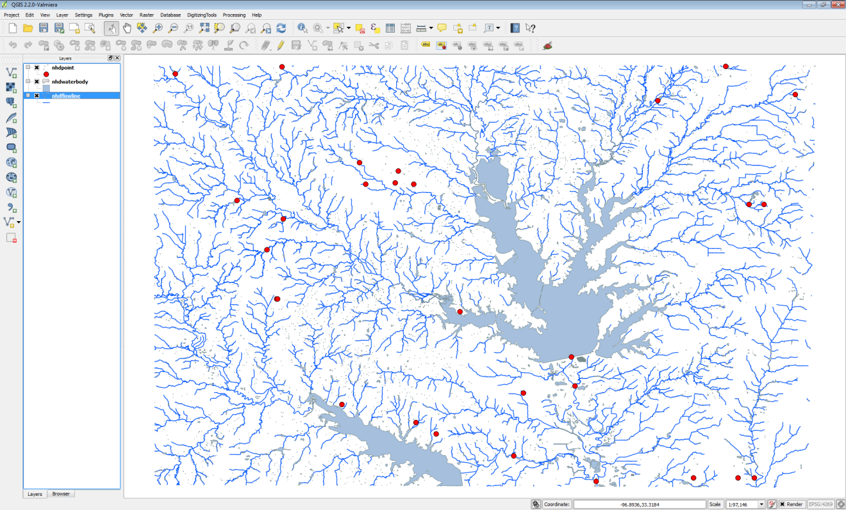

**Figure 7: QGIS Desktop with new SpatiaLite layer added to map**

1. Open **QGIS Browser**. Expand the **SpatiaLite** database connection. Notice that you are now connected to the NGD.sqlite database (**Figure 8**).

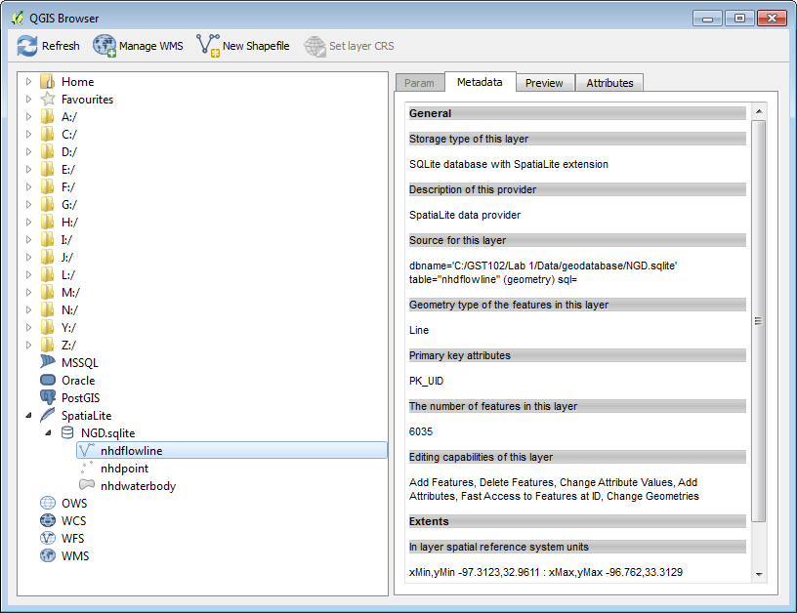

**Figure 8: QGIS Browser showing connection to SpatiaLite database**

1. You have successfully connected to a SpatiaLite geodatabase and imported a shapefile into the database!

**Question # 4:** What is a reason to import source data into a geodatabase?

1. Coordinate Systems

Now you will explore the coordinate reference systems of the lab data.

* + - 1. **Open QGIS Browser**.
      2. By using the **Metadata** tab identify the coordinate reference system for the following datasets. Record your answers below:

**Question #5:**

* + - * 1. St48_d00.shp:
        2. texasdem_tsms.img:
        3. TxDOT_ARPRT_SMALL.shp
      1. Now, close QGIS Browser and QGIS Desktop. Start **QGIS Desktop** creating a new blank map.
      2. **Add** the **BTS_AIRPORT.shp** shapefile to QGIS Desktop by clicking the **Add vector data** button and browsing for the shapefile.
      3. To identify the coordinate system of the shapefile right click and choose **Properties** from the context menu. Click on the **General** tab. Under **Coordinate reference system** you’ll see the CRS.

**Question #6: What is the current coordinate system of this data?**

* + - 1. Let us say for purposes of our analysis that we would like to change the coordinate system of the BTS_Airport.shp layer.
      2. **Right click** on the layer in the Table of Contents and choose **Save as**….
      3. Reproject this layer to **UTM Zone 14, NAD83 (Figure 9).**

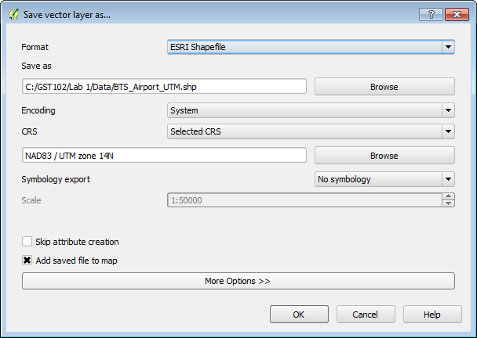

**Figure 9: Save vector layer as…**

1. GIS Data Attributes and Attribute Tables
   * + 1. If you have previously closed QGIS Desktop, reopen it and add the st48_d00.shp shapefile and the TxDOT_ARPRT_SMALL.shp shapefile to your map canvas.
       2. Open the attribute table for the TxDOT_ARPRT_SMALL.shp shapefile by **right-clicking 🡪Open Attribute Table.**

**Question #7: How many records are in this table?**

**Question #8: How many attributes does each point in this shapefile have?**

* + - 1. Open the attribute table for the st48_d00.shp shapefile.

**Question #9: How many records are in this table?**

**Question #10: How many attributes does the polygon in this shapefile have?**

**Question #11: If you wanted to identify all Regional airports from the TxDOT_ARPRT_SMALL shapefile how would you do that?**

5 Conclusion

In this lab, you were able to identify the data models, geometry and number of features for several lab data sets. You connected to a SpatiaLite geodatabase and imported a shapefile into it. You identified the coordinate reference systems of data and reprojected a dataset into a new shapefile. Finally you reviewed working with attribute tables. Knowing how to determine the characteristics of datasets is a necessary step in spatial analysis.

6 Discussion Questions

1. What is the importance of coordinate systems? Why are there so many different coordinate systems and map projections?
2. Describe the pros and cons of rasters and vectors.